

WEB-BASED INTERFACE DESIGN (CSF3133)

Lab Report 3

Name: Fatin Nurain binti Alham Matric: S75855
Date: 5 November 2025 Group: K4
Programme: Bachelor of Computer Science (Software Engineering) With Honors Course Lecture: Assoc.Prof.Ts.Dr.Wan Nural Jawahir
Lab Moderator: Madam Wan Fatin Fatihah binti Yahya

3.2 Block and Inline Elements

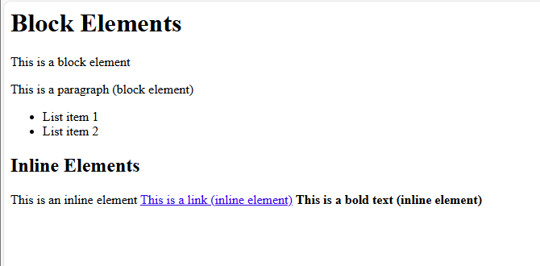

3.3 Using <div> to Organize Content

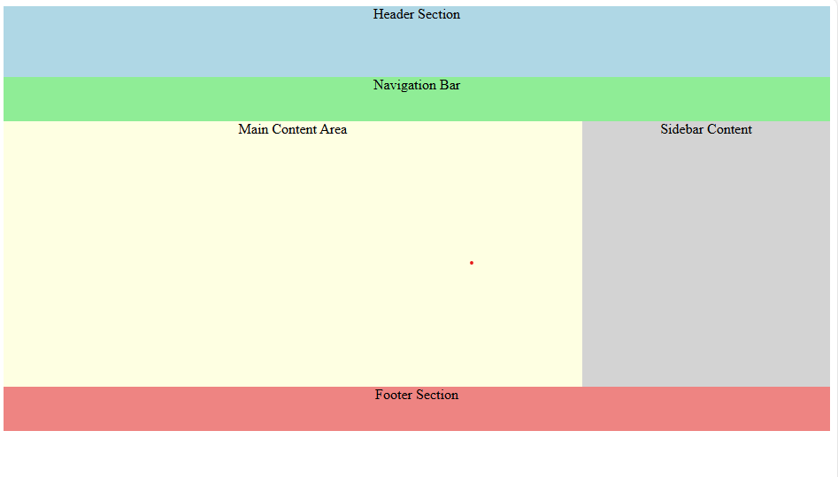
3.4 Understanding HTML Entities

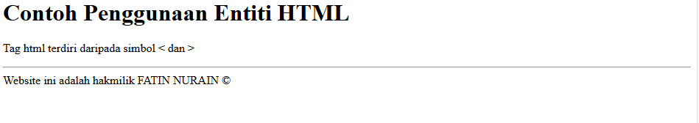
3.5 Hypertext Mark Up Language 5 (HTML5)

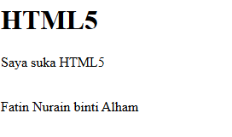
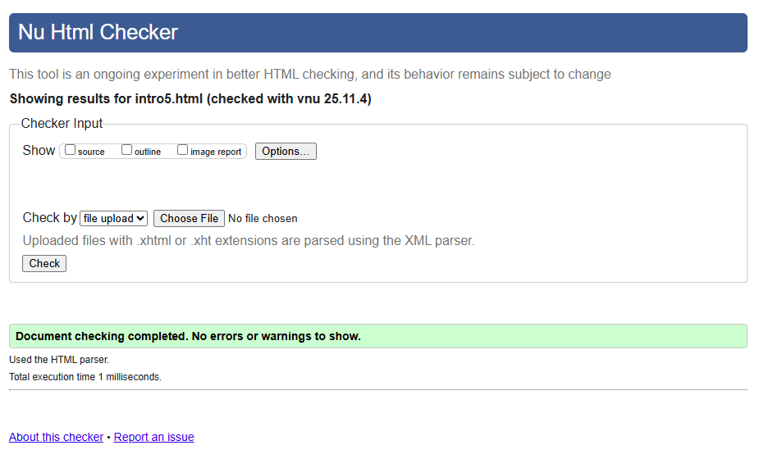
3.6 Form Elements in HTML5

3.6.1 Input Elements in HTML5

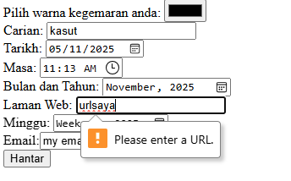
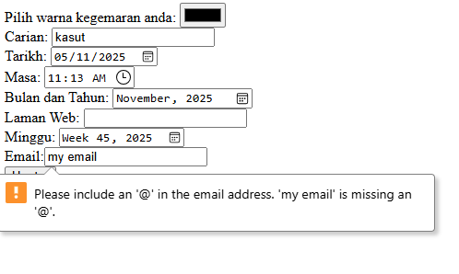

3.6.2 Attributes for Input HTML5

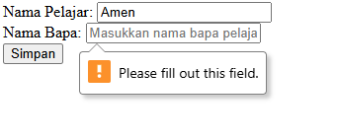

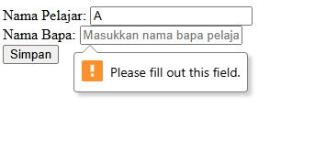

3.6.3 HTML5 <output> element

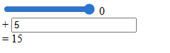
3.7 Lab Exercise 3

Code:
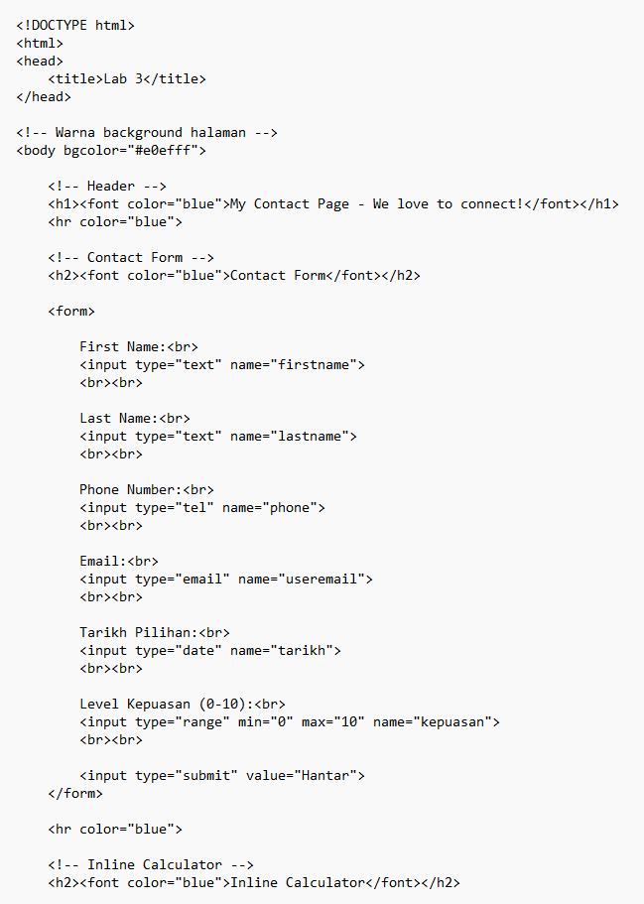

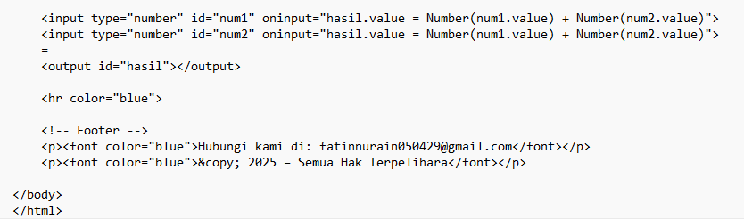

Output:

